INTERFACE:

EXCEPTION HANDLING:

EXAMPLE 2:

Same Example with different O/P:

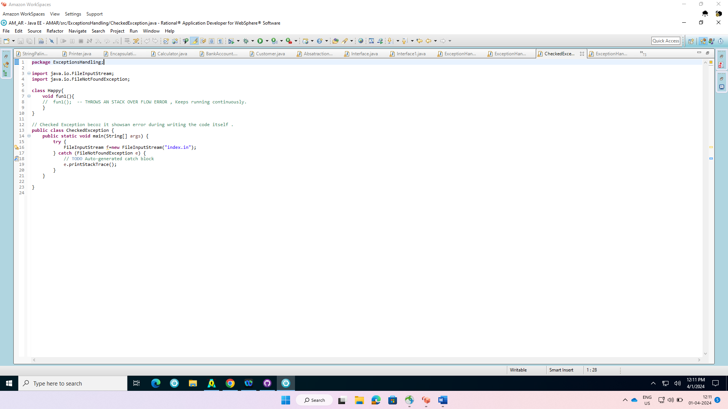

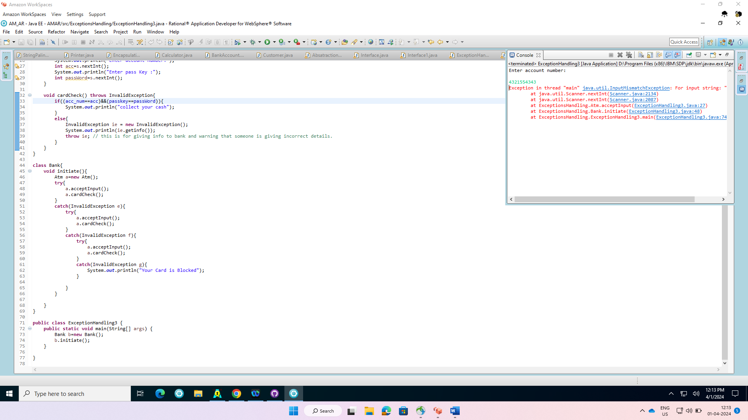

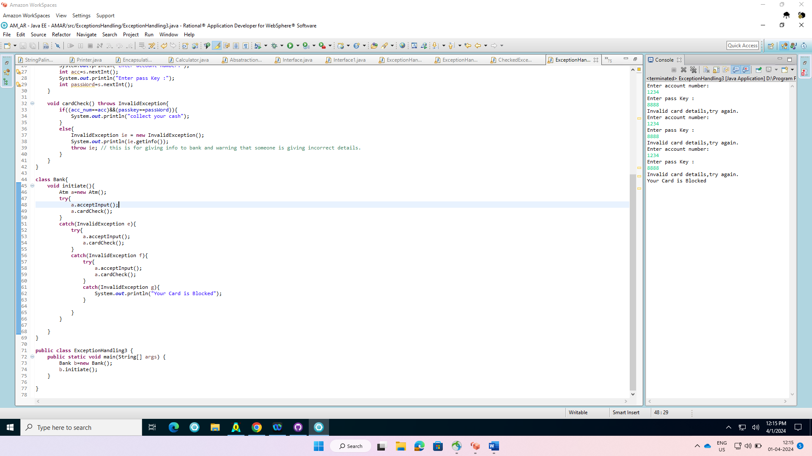

Another Exception Handling:

LiskoRules In Exception Handling:

THREADS:

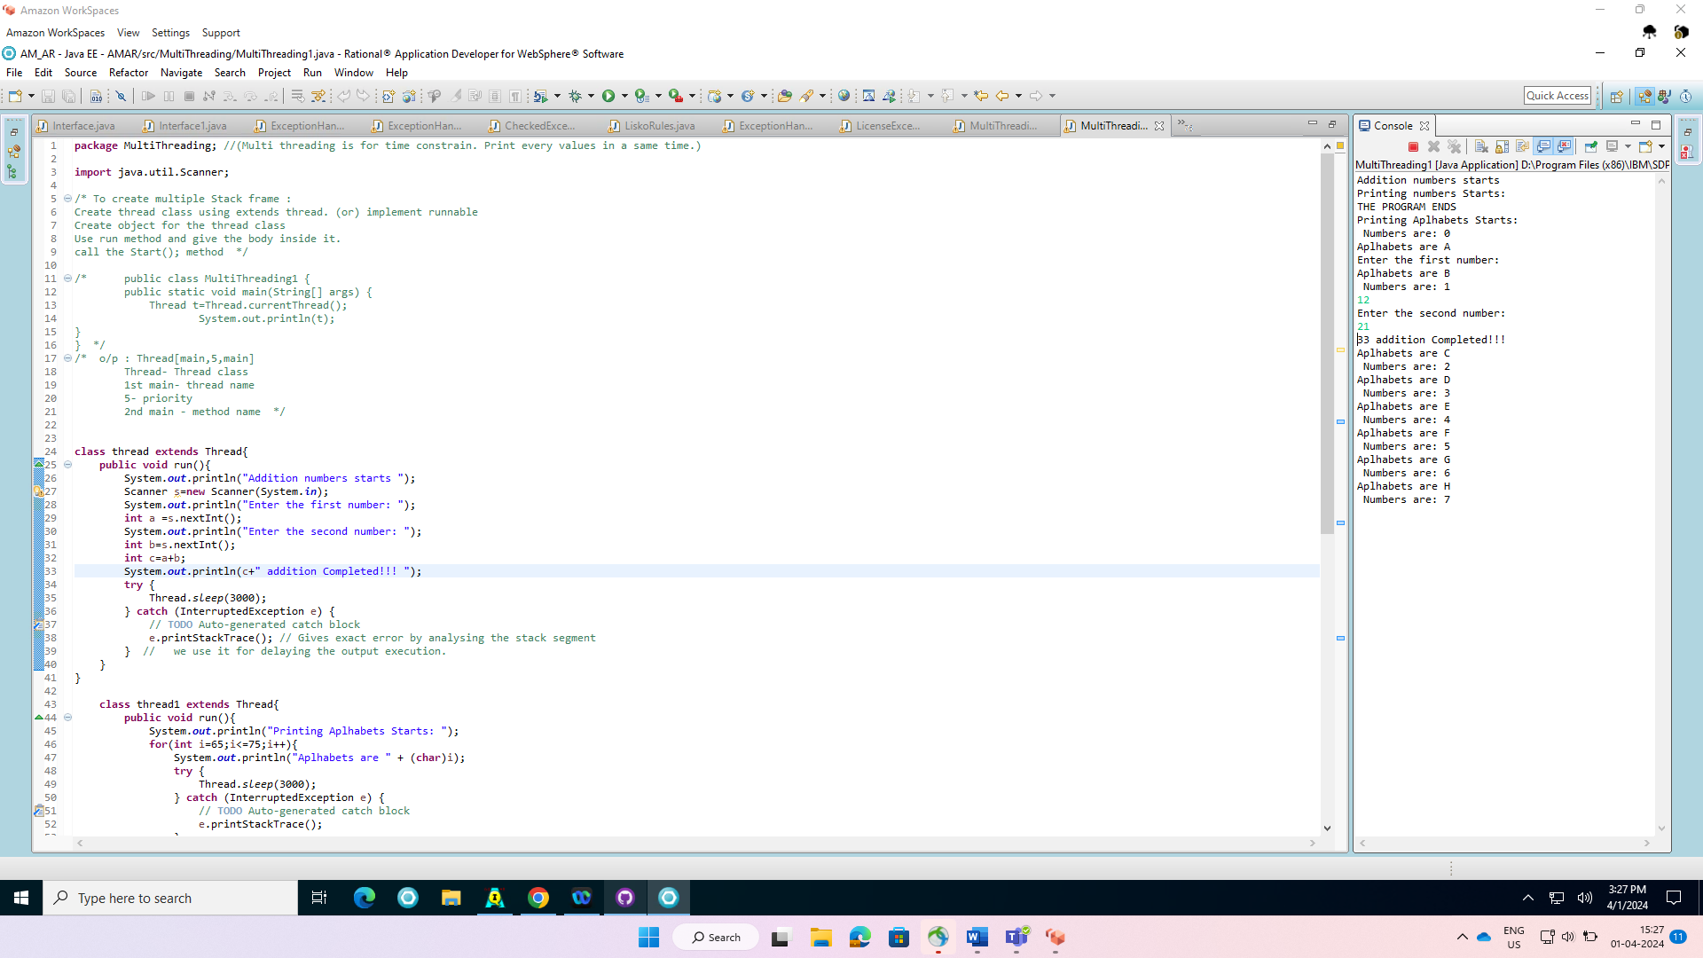

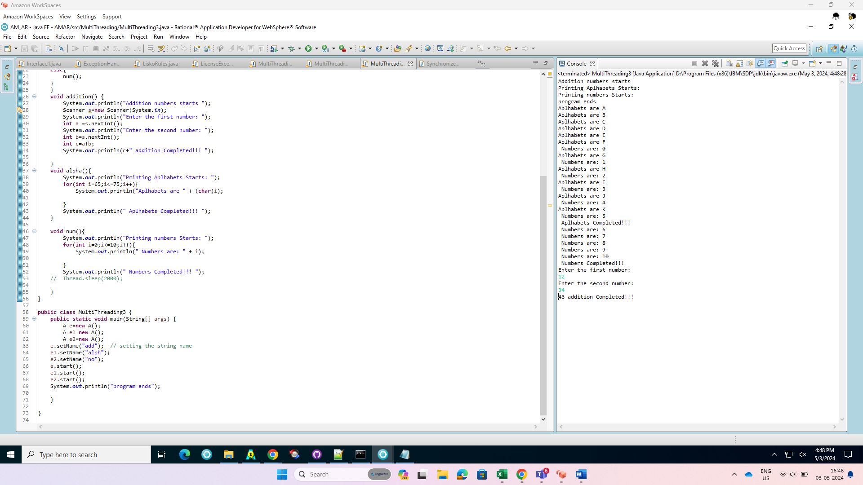

Deadlock:

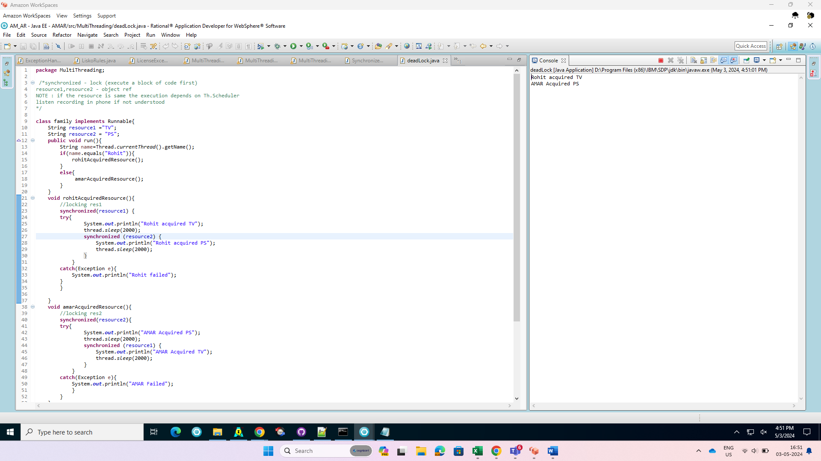

Synchronized:

